1. 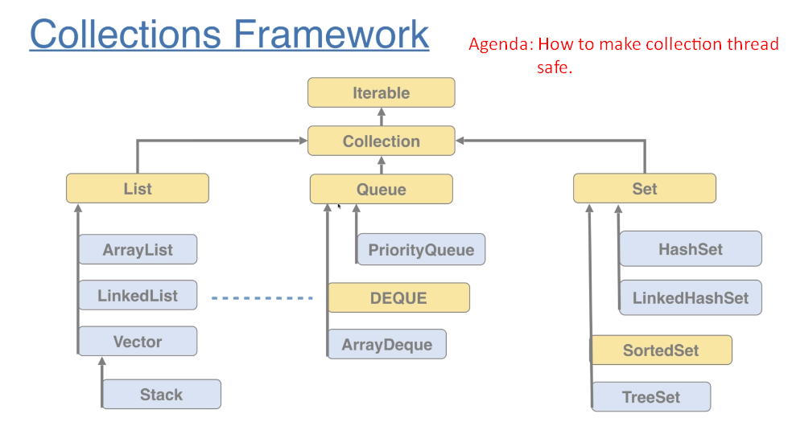
2. 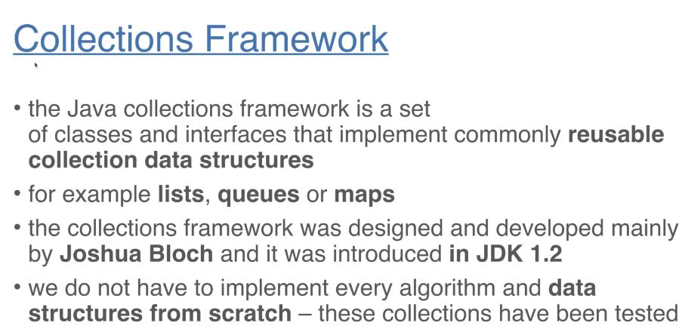
3. 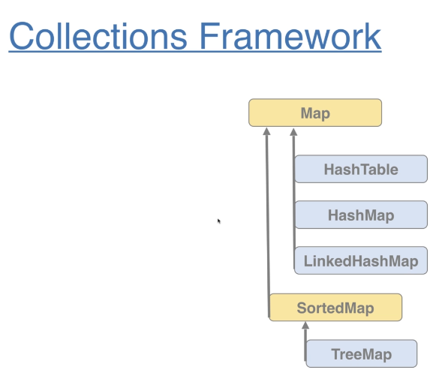
4. Most of these data structures are not thread-safe. In multi-threading environment, we’re going to end up in inconsistent state.
5. **Thread-Safe**: Vector, Hashtable.
6. 